Name: Yichao Xu

Student Number: 2012990920

## The project is in the implementation phase. The user interface and the parts of the game logic have been implemented. In addition, the interface design is changed.

### 1. Game UI:

The game user interface currently has been completed implemented. Compared with the previous design of the game map, the design of game map changes from 3D to 2D. The different continent on the map will be colourized by different colours and the colour bounder of each area are changed from green to black to make the map clearer. Additionally, the design of game buttons changes from icon to text-based and the extra “Setting Button” and “Exit Button” are added.

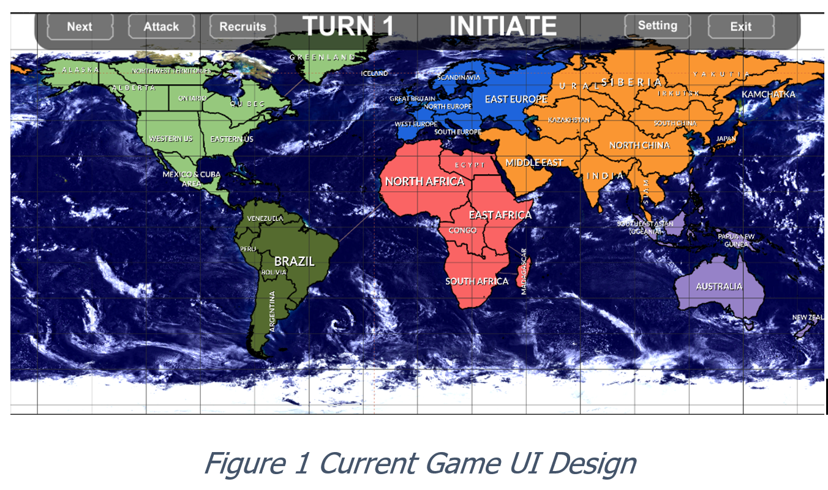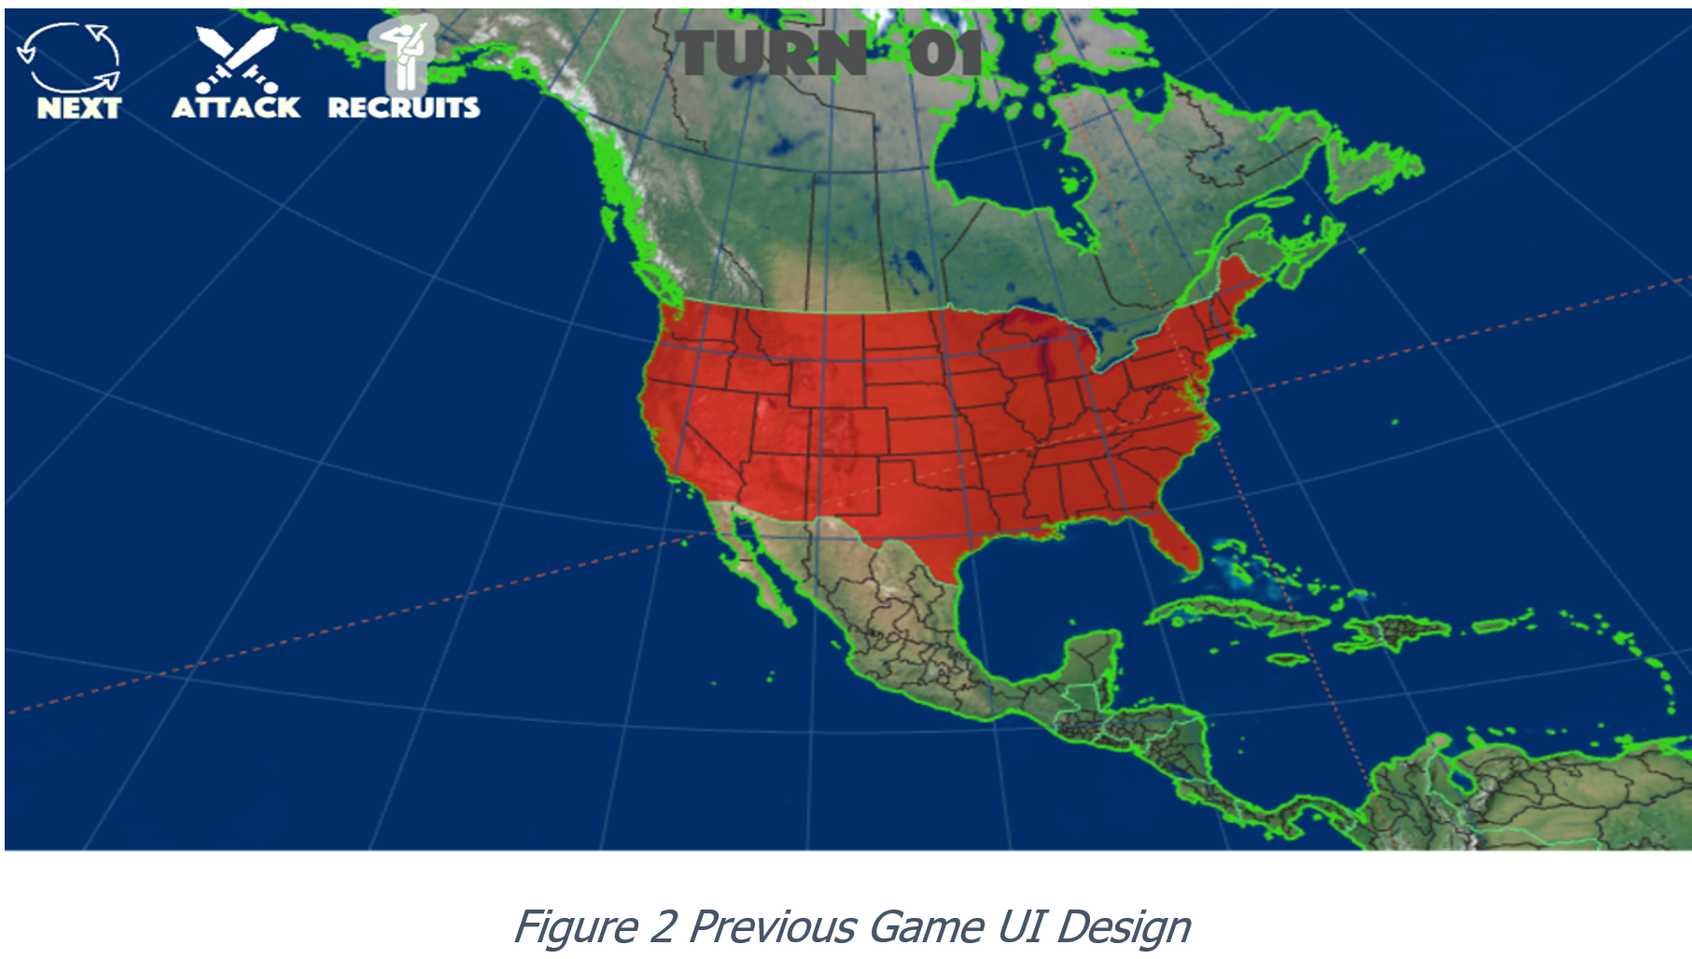

## 2. Game Logic:

The game map area selection and attack functionality have been implemented.

### 2.1 Selection

In the following figure 3, the “IRKUTSK” area is selected. As the figure shown, the colour of the selected area will become red and the colour of nearby areas will become grey.

### 2.2 Movement

Figure 4 shows the situation when the player moves an army from “WESTERN US” area to “ALBERTA” area.

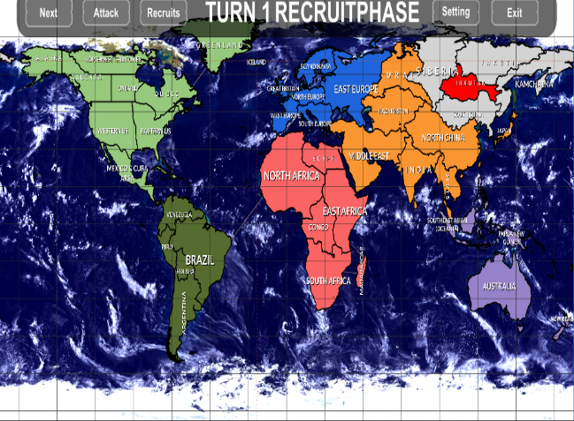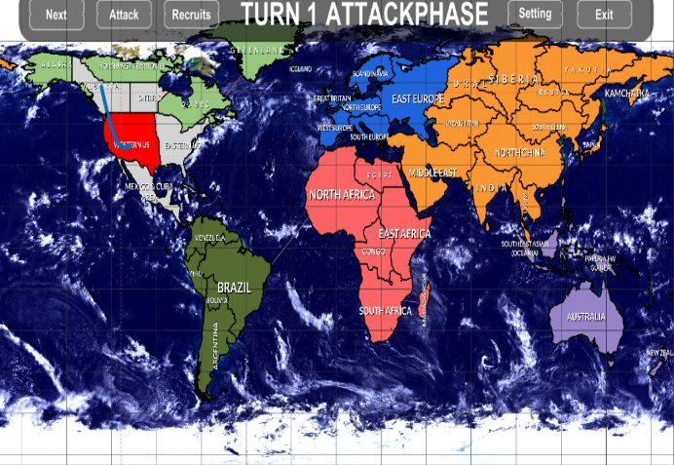

Figure 3 Select IRKUTSK Area Figure 4 Move Army from WESTERN US to ALBERTA